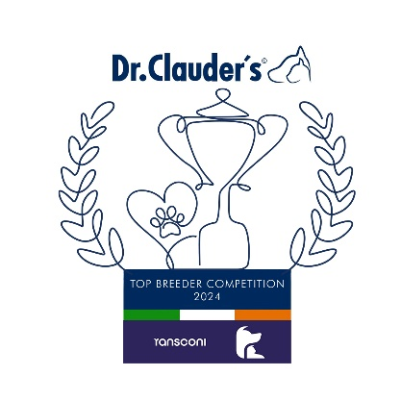

**Group Leaders**

**Gulliagh Irish Wolfhounds (39)**

**AFGHAN HOUND**

Ms F Jd Tromp (Popovs) 25

**AZAWAKH**

Mr Kieran Young (Stonemartin) 24

**BORZOI**

Olga Barkovskaya (Cavallierik) 31

**DEERHOUND**

Mrs McAlpine (Humbiehounds) 11

**GREYHOUND**

Viara Gentchev (Greyfort) 16

**IRISH WOLFHOUND**

**Tim, Marion & Ian Finney (Gulliagh) 39**

**ITALIAN GREYHOUND**

M.Myshkovskaya (Sunnymoon Place) 20

**SALUKI**

Breda Dunne (Saffurah) 18

**SLOUGHI**

Valentina Schachinger (De Polvo Magico) 10

**WHIPPET**

Messrs Khan,Bartusch & Demmerling(Gentle Mind) 30

**GROUP 10**

**Congratulations to the Leaders**

**in the DR CLAUDERS**

**Top Breeder Competition 2024**

The competition identifies the most consistent Breeders of top winning dogs at All Breed Championship Shows within each breed and ran from

1st January to 31st December, 2024

Results up to and including IKC October Ch Show.

**Breeders gain points from Green Star wins at**

**ALL BREED CHAMPIONSHIP SHOWS as follows:**

**5 POINTS** awarded for the first Green Star won by a dog of their breeding

**1 POINT** awarded for subsequent Green Stars won by that same dog.

Each Breed Winner will receive a Diploma, Rosette and Product

Each Group Winner will receive a Diploma, Rosette, Crystal and Product

There will also be a prize for the Overall Winner