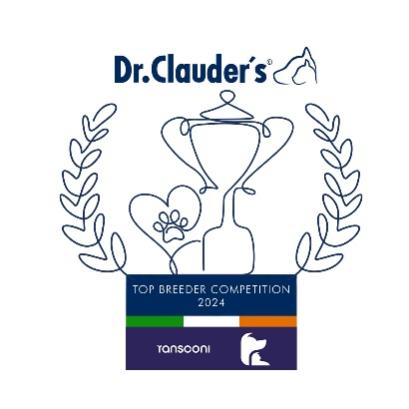

**AFFENPINSCHER**

Delia Shepherd (Avantgarde) 13

**BERNESE MOUNTAIN DOG**

Mrs Declerck (De Zandvijver) 27

**BLACK RUSSIAN TERRIER**

Adam Florczuk 22

**BOXER**

Amanda Payne (Willow) 34

**BULLDOG**

Mr Brosnan (Starbornbullies) 52

**BULLMASTIFF**

K.Kvjatkovska (Aralinn) 35

**CAUSASIAN SHEPHERD DOG**

D.Strazda (Dominus Manerli) 9

**DOBERMANN PINSCHER**

Billy Henderson (Tuwos) 47

**DOGO ARGENTINO**

Marek Males (La Fiera Blanca) 25

**DOGUE DE BORDEAUX**

Marvello Rottura (Dei Dogue Delle Cave) 24

**ESTRALA MOUNTAIN DOG (Long Haired)**

Alan Sawyer (Tarsneyisle) 11

Monika Zwesken (Da Quinta Moinhos Das Almas)11

**GERMAN PINSCHER**

Debbie Gamble (Wot A Thriller) 16

**GIANT SCHNAUZER**

Eilish Moffat (Marblehill) 30

**Group 2 Leader**

**Parleshan Saint Bernards (74)**

**GROUP 2**

**GREAT DANE**

Sonya Duffy (Kinnegans) 32

**HOVAWART**

Michael Murphy (Micona) 48

**ITALIAN CORSO DOG**

Jackie Prior (Jacdmar) 46

**LEONBERGER**

Diane & Lauren Whan (Sulandi) 46

**MASTIFF**

Mr & Mrs Coulman-Hole (Womlu) 26

**NEAPOLITAN MASTIFF**

Emiliano Messina 8

**NEWFOUNDLAND**

Mr & Mrs Duff (Titanbears) 26

**PINSCHER MINIATURE**

Angela McNally (Assisi) 38

**PYRENEAN MOUNTAIN DOG**

Ms M Morawiak (Mysticelysium) 32

**ROTTWEILER**

Tim Gavin (Ballyseedyrotts) 23

**SCHNAUZER MINIATURE**

Clare Burnett (Moncher) 19

**SCHNAUZER STANDARD**

Phil Boulton (Boujan) 11

**SHAR PEI**

Silvia Vannucci (Huang) 17

**ST BERNARD L/H**

**Mr & Mrs Sheehan (Parleshan) 74**

**ST BERNARD S/H**

Mr & Mrs Sheehan (Parleshan) 34

**Congratulations to the Leaders**

**in the DR CLAUDERS**

**Top Breeder Competition 2024**

The competition identifies the most consistent Breeders of top winning dogs at All Breed Championship Shows within each breed and ran from

1st January to 31st December, 2024

(Results up to and Including IKC October Ch Show)

**Breeders gain points from Green Star wins at**

**ALL BREED CHAMPIONSHIP SHOWS as follows:**

**5 POINTS** awarded for the first Green Star won by a dog of their breeding

**1 POINT** awarded for subsequent Green Stars won by that same dog.

Each Breed Winner will receive a Diploma, Rosette and Product

Each Group Winner will receive a Diploma, Rosette, Crystal and Product

There will also be a prize for the Overall WinnerKI.