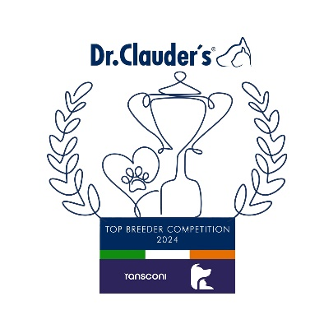

**IRISH TERRIER**

John Canty (Megacant) 20

**JACK RUSSELL TERRIER**

Marianne Dunne (Krisbos) 28

**KERRY BLUE TERRIER**

Pat O’Regan (Brykar) 35

**LAKELAND TERRIER**

Messrs Anderson & Watt (Nisyros) 13

**MANCHESTER TERRIER**

Mrs Barton (Davlynn) 7

**NORFOLK TERRIER**

Wendy Bentley (Wenark) 15

Cathy Morgan (Belleville) 15

**NORWICH TERRIER**

Lesley Crawley (Ragus) 13

**PARSON RUSSELL TERRIER**

Mr J.Manson (Foxfur) 26

**SCOTTISH TERRIER**

Betty Smit-Kamerbeek (Lucias Dream) 19

**SEALYAM TERRIER**

C & W.Stamm (Taita’s Ushabti) 10

**SKYE TERRIER**

Jana Pickova (Sagasky) 22

**STAFFORDSHIRE BULL TERRIER**

James Byrnes (Lackyle) 32

**WELSH TERRIER**

Lucie Lieblova (Od Guvernera) 20

**WEST HIGHLAND WHITE TERRIER**

Francesco Zaccariello (Zackshine) 25

**YORKSHIRE TERRIER**

V.Hulmes & L.Taylor (Bierlyns) 24

**AIREDALE TERRIER**

Mr and Mrs Toulson (Toulsyork) 33

**AMERICAN STAFFORDSHIRE TERRIER**

Hanna Bros-Zaleska (Just Obsession) 25

Lilianna Ceglarska (Lilyspride) 25

**AUSTRALIAN SILKY TERRIER**

Kathleen Whiteford (Crestford) 5

**BEDLINGTON TERRIER**

Mrs D.Boyd (Agnellino) 33

**BORDER TERRIER**

Mr & Mrs Atkinson (Raedwulf) 19

**BULL TERRIER**

Kevin Robinson 24

**BULL TERRIER MINIATURE**

Y.Streltsova (Yanni House) 17

**CAIRN TERRIER**

**Marie Hogarty (Cadagio) 57**

**CESKY TERRIER**

Darwin Martin (Gaelgorm) 11

**DANDIE DINMONT TERRIER**

Ali Cox-Purcell (Puddockswell) 28

**ENGLISH TOY TERRIER**

Ms J.Crowley (Adargwn) 25

**FOX TERRIER SMOOTH**

Ross Delmar (Shillelagh) 20

**FOX TERRIER WIRE**

Mervyn Thompson (Burrencroft) 31

**IRISH GLEN OF IMAAL TERRIER**

Mrs A White (Abberann) 38

**IRISH SOFT COATED WHEATEN TERRIER**

Bev Hanna (Kinaelan) 21

**Group 3 Leaders**

**Cadagio Cairn Terriers (57)**

**GROUP 3**

**Congratulations to the Leaders**

**in the DR CLAUDERS**

**Top Breeder Competition 2024**

The competition identifies the most consistent Breeders of top winning dogs at All Breed Championship Shows within each breed and ran from

1st January to 31st December, 2024

(Results up to and including IKC October Ch Show)

**Breeders gain points from Green Star wins at**

**ALL BREED CHAMPIONSHIP SHOWS as follows:**

**5 POINTS** awarded for the first Green Star won by a dog of their breeding

**1 POINT** awarded for subsequent Green Stars won by that same dog.

Each Breed Winner will receive a Diploma, Rosette and Product

Each Group Winner will receive a Diploma, Rosette, Crystal and Product

There will also be a prize for the Overall Winner