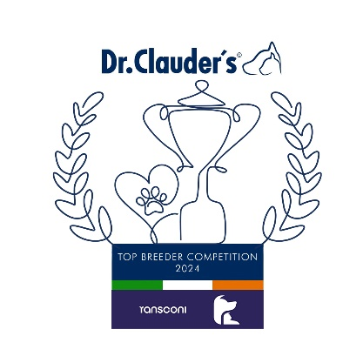

**ARIEGEOIS**

Luca Baldoni (Baldoni) 7

**BASSET BLEU DE GASCOGNE**

Mme Dominique Boutet (Des Vallees Longeronnaises) 16

**BASSET FAUVE DE BRETAGNE**

**Mr and Mrs Blevins (Blevwil) 51**

**BASSET HOUND**

Mr and Mrs Blevins (Blevwil) 50

**BAVARIAN MOUNTAIN SCENTHOUNDS**

Mr Laurence Taaffe (Tobyhill) 11

**BEAGLES**

Eamon Murray (Heathergrove) 29

**BLACK & TAN COONHOUND**

Mesdames Park, Hough & Kelly (Ladysdale) 37

**BLOODHOUND**

Evelyn Burnside & Rob Manley (Houndseeker) 5

**DALMATIAN**

Martina Bermingham (Lornlee) 32

**GRAND BASSET GRIFFON VENDEEN**

Mrs & Miss McGregor (Claela) 30

**KERRY BEAGLE**

Messrs O’Dwyer & Irving (Ravensring) 17

**PETITE BASSET GRIFFON VENDEEN**

Mr & Mrs Foote & Miss McAuley (Erylan) 42

**PORCELAINE**

Kinga Strizovic (Sibiliani) 12

**RHODESIAN RIDGEBACK**

Julie Pratt (Hooz) 21

**Congratulations to the Leaders**

**in the DR CLAUDERS**

**Top Breeder Competition 2024**

The competition identifies the most consistent Breeders of top winning dogs at All Breed Championship Shows within each breed and ran from

1st January to 31st December, 2024

Results up to and including IKC October Ch Show.

**Breeders gain points from Green Star wins at**

**ALL BREED CHAMPIONSHIP SHOWS as follows:**

**5 POINTS** awarded for the first Green Star won by a dog of their breeding

**1 POINT** awarded for subsequent Green Stars won by that same dog.

Each Breed Winner will receive a Diploma, Rosette and Product

Each Group Winner will receive a Diploma, Rosette, Crystal and Product

There will also be a prize for the Overall Winner

**Group 6 Leaders**

**Blevwil Basset Fauve De Bretagne (51)**

**GROUP 6**