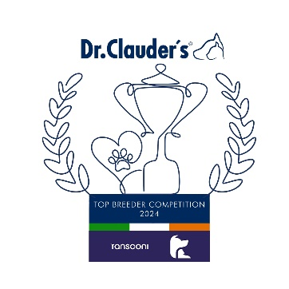

**GERMAN SHEPHERD DOG**

Martin Kelly (Konigshof) 32

**GERMAN SHEPHERD L/C**

Albert Balmer (Alberdale) 22

**KOMONDOR**

Toni Saunders (Regerastace) 19

**LANCASHIRE HEELER**

Mrs Enid Lord (Foxthyme) 10

**MUDI**

**Toni Saunders (Regerastace) 64**

**OLD ENGLISH SHEEPDOG**

Geraldine Mulrooney (Bellablue) 32

**PUMI**

Gabriella Kassai (Serteperti) 36

**PYRENEAN SHEEPDOG**

Mr & Mrs Flint (Sandytrail) 7

**SCHIPPERKE**

Mary Deats (Aradet) 6

Jan Mance (Ryeman) 6

Mr & Mrs & Miss Donaldson (Zorbaloo) 6

**SHETLAND SHEEPDOG**

Grainne Keeling (Kishdigra) 35

**SLOVAKIAN CHUVACH**

Olga Buresova (Z Hanacke Strane) 15

**TATRA SHEPHERD DOG**

Michal Stoch Gronkowion (Stochgronkowion) 9

**WELSH CORGI CARDIGAN**

D.Kovacs (Arcanedale) 11

**WELSH CORGI PEMBROKE**

Alan Matthews (Craigycor) 42

**WHITE SWISS SHEPHERD**

Erik Lajbner (Arlo Niktel) 33

**AUSTRALIAN KELPIE**

F. & B.Soldati 13

**AUSTRALIAN SHEPHERD DOG**

Karen McDevitt (Caronlea) 58

**BELGIAN SHEPHERD GROENENDAEL**

Paul, Jean & Kelly Lawless (Revloch) 25

**BELGIAN SHEPHERD LAEKENOIS**

Jan Ralph (Bonvivant) 7

**BELGIAN SHEPHERD MALINOIS**

Stijn Van Hamme (V.D Vaardekenshoeve) 38

**BERGAMASCO**

Mr & Mrs Sandford (Boscoantico) 7

Fabrizio Nava 7

**BOHEMIAN SHEEPDOG**

Alena Kromkova 7

**BOUVIER DES FLANDRES**

Clare Burnett (Mon Cher) 59

**BRIARDS**

Mrs C.Foster (Fostebrie) 19

**CATALAN SHEEPDOGS**

Mr & Mrs Fieldsend (Starwell) 16

**COLLIE BEARDED**

Cornelia Loest & Paul Roeland (Firstprizebears) 40

**COLLIE BORDER**

Mr & Mrs Connolly (Huntly) 49

**COLLIE ROUGH**

Tom Wall (Daliyhaa) 38

**COLLIE SMOOTH**

Ewa Bjurstrom (Straightlines) 19

**CZECH WOLFDOGS**

Alex De Les Eres 8

**GROUP 1**

**Group 1 Winners**

**Regerastace Mudi (64)**

**D**

**Congratulations to the Winners**

**in the DR CLAUDERS**

**Top Breeder Competition 2024**

The competition identifies the most consistent Breeders of top winning dogs at All Breed Championship Shows within each breed and ran from

1st January to 31st December, 2024

(Results up to and Including DDSS Ch Show)

**Breeders gain points from Green Star wins at**

**ALL BREED CHAMPIONSHIP SHOWS as follows:**

**5 POINTS** awarded for the first Green Star won by a dog of their breeding

**1 POINT** awarded for subsequent Green Stars won by that same dog.

Each Breed Winner will receive a Diploma, Rosette and Product

Each Group Winner will receive a Diploma, Rosette, Crystal and Product

There will also be a prize for the Overall Winner