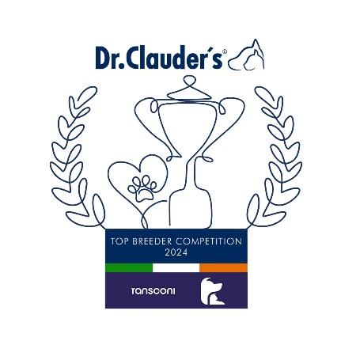

**AKITA INU**

Mr J McGrath (Ryuukita) 22

**ALASKAN MALAMUTE**

Grainne Keeling (Kishdigra) 51

**AMERICAN AKITA**

Craig Bannon & Niamh Carroll (Cannonbar) 49

**BASENJI**

Charlotte Trasler (Dobri’s) 37

**CANADIAN ESKIMO DOG**

Miss S Atkins (Qimugta) 29

**CHOW CHOW**

Mr & Mrs Campbell (Kuanyin) 45

**CIRNECO DELL ETNA**

Nancy Wight & Sarah Wolfe (Rockin Hearts) 21

**EURASIER**

Mariette Styrenius (Polkasvalpar) 5

**GERMAN SPITZ KLEIN**

Margaret Corr (Crystalclear) 20

**GERMAN SPITZ MITTEL**

Kevin O’Leary (Cadasaro) 45

**GREENLAND DOGS**

Miss A.Blaney (Fenrirkin) 9

**IBIZAN HOUND**

Mr & Mrs Carter (Afilador) 9

**JAPANESE SHIBA INU**

**Ms M Jackson & Miss E Wright (Lacsar) 101**

**Group Winner and Overall Top Breeder All Breeds**

**Lacsar Japanese Shiba Inu (101)**

**Congratulations to the Winners**

**in the DR CLAUDERS**

**Top Breeder Competition 2024**

The competition identifies the most consistent Breeders of top winning dogs at All Breed Championship Shows within each breed and ran from

1st January to 31st December, 2024

Results up to and including DDSS Ch Show.

**Breeders gain points from Green Star wins at**

**ALL BREED CHAMPIONSHIP SHOWS as follows:**

**5 POINTS** awarded for the first Green Star won by a dog of their breeding

**1 POINT** awarded for subsequent Green Stars won by that same dog.

Each Breed Winner will receive a Diploma, Rosette and Product

Each Group Winner will receive a Diploma, Rosette, Crystal and Product

There will also be a prize for the Overall Winner

**JAPANESE SPITZ**

Miss Y Anderson (Georgeglen) 28

**KEESHONDS**

Mrs Hopkins (Serenaubach) 6

**KOREA JINDO DOG**

Rebecca Cunningham (Yulyeong) 12

**MEXICAN HAIRLESS MINIATURE**

Davila Sixto (Langarica) 11

**NORWEGIAN BUHUND**

Mr & Mrs Frost (Frostien) 43

**NORWEGIAN ELKHOUND**

Mr and Mrs Middleton (Graythor) 29

**PHARAOH HOUND**

M.A Obolenskaya (Litlars) 35

**POMERANIAN**

James Newman & Sean Carroll (Belliver) 84

**SAMOYED**

O.Drombovskaya (Radost Zhizni) 21

**SIBERIAN HUSKY**

Jose Luis Gomez Sanchez (Winter Melody) 21

**SWEDISH LAPPHUND**

Ms Kiere (Sami - Ursus) 8

**SWEDISH VALLHUND**

Ms L Patterson (Eriksfjord) 10

**THAI RIDGEBACK**

Ognjen & Helga Abramovic (Dorsus) 6

**YAKUTIAN LAIKA**

Grazyna Stachowicz (Zhowerli) 5

**GROUP 5**