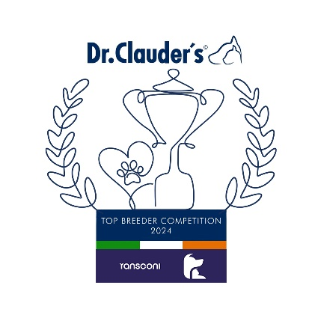

**Group Winners**

**Ashaka Japanese Chin (60)**

**BICHON FRISE**

Tara Bagnall (Glenclor) 26

**BOLOGNESE**

Mrs Van Driel 8

**BOSTON TERRIER**

Marion Campbell (Lisvarna) 48

**CAVALIER KING CHARLES SPANIEL**

Miyuki Kotani & Kitty Conlan (Rathbrist) 54

**CHIHUAHUA L/C**

Ms F.Kelly (Frapachi) 36

**CHIHUAHUA S/C**

Mr M.O’Sullivan (Lestatt) 36

Ms F.Kelly (Frapachi) 36

**CHINESE CRESTED**

Ms G & Ms A.Mooney (Talltales) 31

**COTON DU TULEAR**

Elisabetta De Luca (Cotonbrie) 26

**FRENCH BULLDOG**

Siobhan Minogue (Byrmin) 25

**GRIFFON BRUXELLOIS**

Ms Zadoinova (Star Griff) 20

**HAVANESE**

Mr & Mrs Blevins (Blevwil) 28

**JAPANESE CHIN**

**Marie Thorpe (Ashaka) 60**

**KING CHARLES SPANIEL**

Mrs Kendall (Headra) 25

**LHASA APSO**

Miss J Brown (Shayniken) 23

.

**Congratulations to the Winners**

**in the DR CLAUDERS**

**Top Breeder Competition 2024**

The competition identifies the most consistent Breeders of top winning dogs at All Breed Championship Shows within each breed and ran from

1st January to 31st December, 2024

Results up to and including DDSS Ch Show.

**Breeders gain points from Green Star wins at**

**ALL BREED CHAMPIONSHIP SHOWS as follows:**

**5 POINTS** awarded for the first Green Star won by a dog of their breeding

**1 POINT** awarded for subsequent Green Stars won by that same dog.

Each Breed Winner will receive a Diploma, Rosette and Product

Each Group Winner will receive a Diploma, Rosette, Crystal and Product

There will also be a prize for the Overall Winner

**GROUP 9**

**LOWCHEN**

Bozena Smialowska (Dart‘s Defender) 49

**MALTESE**

Ms & Mrs Jackson (Benatone) 41

**PAPILLON**

Dahila Uotila (Tres Cherie) 29

**PEKINGESE**

Raymond O’Neill (Trendylook) 54

**PHALENE**

Joanna & Karolina Ciereszko (Vive Vanette) 26

**POODLES MEDIUM**

Orlaith Keenan (Sleepybrook) 33

**POODLES MIN**

Heather Hayden (Vogue Red) 20

**POODLES STANDARD**

Julia Wells (Volgarus) 22

**POODLES TOY**

Messrs Gadsby, Lynn & Isherwood (Afterglow) 46

**PUG**

Clodagh Fallon (Clodana) 36

**RUSSIAN TOY TERRIER L/C**

Inna Larionova (Grande Misterio) 8

**RUSSIAN TOY TERRIER S/C**

Angela Codling (Lingkiss) 8

**RUSSKAYA TSVETKAYA BOLONKA**

Ms. Biedulska 5

**SHIH TZU**

Boguslawa Lenart (Solaris Avis) 23

**TIBETAN SPANIELS**

David & the late Fiona Hurley (Lahume) 32

**TIBETAN TERRIER**

Michael Scanlon (Cliffmeadow) 26