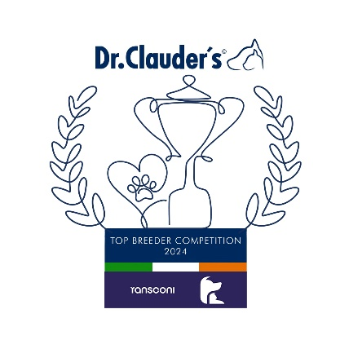

**Congratulations to the Winners**

**in the DR CLAUDERS**

**Top Breeder Competition 2024**

The competition identifies the most consistent Breeders of top winning dogs at All Breed Championship Shows within each breed and ran from

1st January to 31st December, 2024

Results up to and including DDSS Ch Show.

**Breeders gain points from Green Star wins at**

**ALL BREED CHAMPIONSHIP SHOWS as follows:**

**5 POINTS** awarded for the first Green Star won by a dog of their breeding

**1 POINT** awarded for subsequent Green Stars won by that same dog.

Each Breed Winner will receive a Diploma, Rosette and Product

Each Group Winner will receive a Diploma, Rosette, Crystal and Product

There will also be a prize for the Overall Winner

**Group Winners**

**Roslieve Labrador Retrievers (44)**

**BARBET**

Mr Kenyon (Woolimuts) 13

**LAGOTTO ROMAGNOLA**

Bartusch, Demmerling & Khan (Gentle Mind) 10

**PORTUGUESE WATER DOG**

Even Storskogen Prydz (Nadarium) 22

**RETRIEVER CHESAPEAKE BAY**

Mrs Janet Morris (Penrose) 19

**RETRIEVER CURLY COAT**

Marianne Dunne (Krisbos) 6

**RETRIEVER FLAT COAT**

Helen Fox (Blacktoft) 23

**RETRIEVER GOLDEN**

Frank, Bette & Emma Archibald (Abinvale) 22

**RETRIEVER LABRADOR**

**Cyril South (Roslieve) 44**

**RETRIEVER NOVA SCOTIA DUCK TOLLING**

Miss Anstead (Riverwatcher) 22

**SPANIEL AMERICAN COCKER**

Outi Heikkinen (Little Life) 21

**SPANIEL CLUMBER**

Lee Cox (Vanitonia) 23

**SPANIEL COCKER**

Mr, Mrs & Miss McLaren (Bencleuch) 22

**SPANIEL ENGLISH SPRINGER**

Michele Knapp (Templecarraig) 22

**SPANIEL FIELD**

Marjaana Kurri (Icemint) 7

**SPANIEL IRISH WATER**

Rhona Murray (Donncara) 12

Judith Carruthers (Stanegate) 12

**SPANIEL SUSSEX**

Val Davy (Eald) 35

**SPANIEL WELSH SPRINGER**

Catherine McKeon Halpin (Moonlone) 19

Mr & Mrs Douglas (Santallina) 19

**SPANISH WATER DOG**

Marika Fredriksen & Ivor Jelavic (Zorrazo) 7

**GROUP 8**